ID: 960625733

Name: Nisha Patel

1. select p.PNum, p.PName from Project p, Assignment a, Employee e, Department d where d.DName = "Data Conversion" and d.DID = e.DID and e.EID = a.EID and a.PNum = p.PNum;

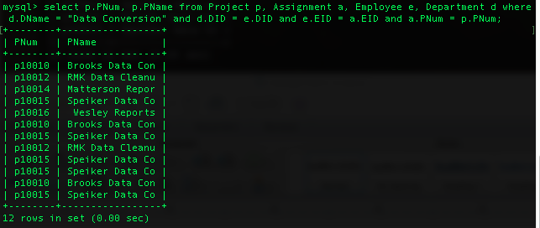

­­

1. select e.EID,e.EName from Employee e, Department d where d.DName = "Client Services" and d.DID = e.DID;

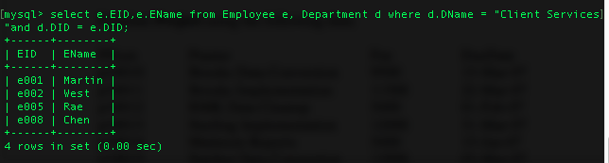

1. select e.EID, e.EName from Employee e, Assignment a where e.EID = a.EID group by a.EID having count (PNum) > 1;

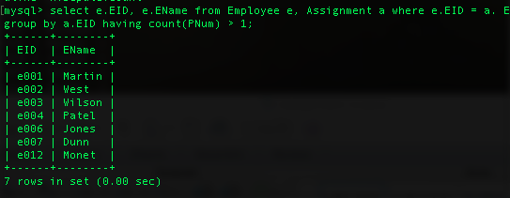

1. update Employee e set e.Salary = e.Salary + 500 where e.EID in (select e.EID from Assignment group by a.EID having sum(a.Hours) > 15;

